**Description Of Piezoelectric Sensor:**

A sensor which works on the principle of piezoelectricity is known as a piezoelectric sensor. Where piezoelectricity is a phenomenon where electricity is generated if mechanical stress is applied to a material. Not all materials have piezoelectric characteristics**.**

**Specification of piezoelectric sensor:**

These sensors contain as Impedance value ≤500Ω.

These sensors generally operate in a temperature range of approximately -20°C to +60°C.

These sensors are to be kept at a temperature between -30°C to +70°C to prevent them from degradation.

These sensors have very low Soldering temperature.

Strain sensitivity of a piezoelectric sensor is 5V/µƐ.

Due to its high flexibility Quartz is the most preferred material as a piezoelectric sensor.

**Piezoelectric Sensor Pin Configuration**

Pin Name Description

Outer Circle This gives Negative output voltage

Inner Circle This gives positive output voltage

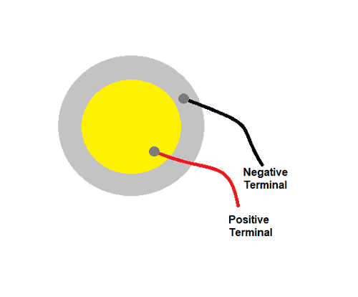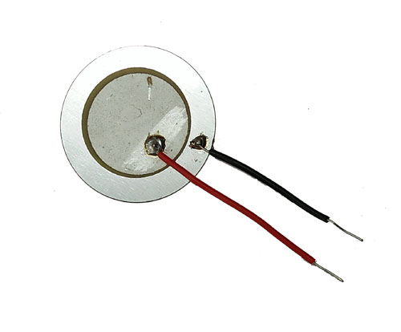

**Working of a Piezoelectric Sensor:**

The commonly measured physical quantities by a piezoelectric sensor are Acceleration and Pressure. Both pressure and acceleration sensors work on the same principle of piezoelectricity but the main difference between them is the way force is applied to their sensing element.

In the pressure sensor, a thin membrane is placed on a massive base to transfer the applied force to the piezoelectric element. Upon application of pressure on this thin membrane, the piezoelectric material gets loaded and starts generating electrical voltages. The produced voltage is proportional to the amount of pressure applied.

In accelerometers, seismic mass is attached to the crystal element to transfer the applied force to piezoelectric materials. When motion is applied, seismic mass load’s the piezoelectric material according to Newton’s second law of motion. The piezoelectric material generates charge used for calibration of motion.

An acceleration compensation element is used along with a pressure sensor as these sensors can pick up unwanted vibrations and show false readings.